**Before Login Questions Workbook**

* Questions Dashboard Explains about what is the BEST Plan & BEST Company for you Country wise(UK & India).
* User has to answer the Questions on the right side in order to get the best plan and which company is giving the suitable plan based on the quiz.

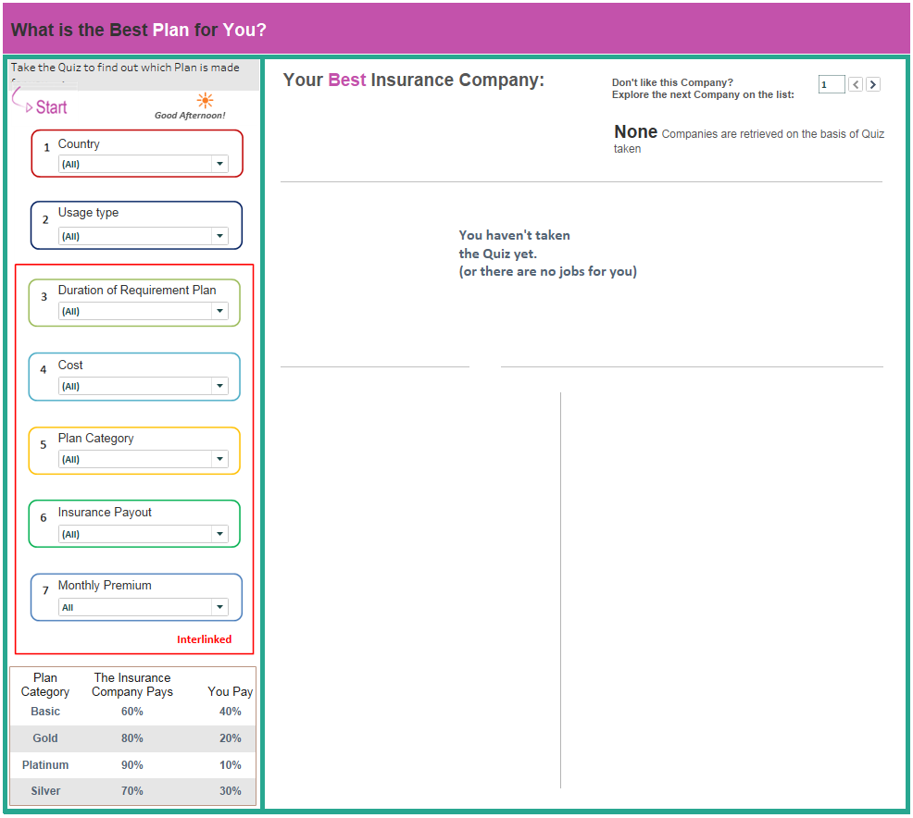

In Above screenshot, User has to take the quiz based on his requirement inorder to get the best plan and company for him.

* After taking the quiz ,

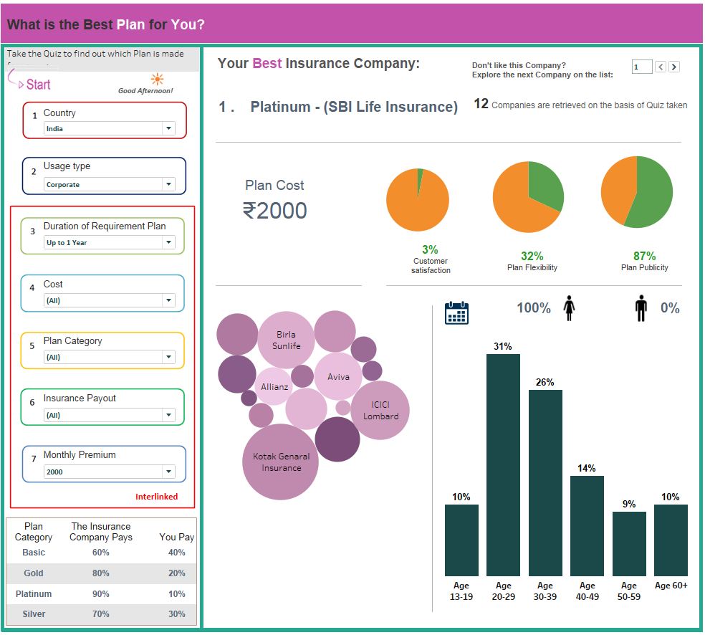

Here the monthly premium lets taken as 500 then we need to select the Duration of Requirement Plan

---up to 3 months ( Plan-Basic)

The monthly premium lets taken as 1000 then we need to select the Duration of requirement plan

---up to 6 months(Plan-Silver)

The monthly premium lets taken as 1500 then we need to select the Duration of requirement plan

---up to 9 months(Plan-Gold)

The monthly premium lets taken as 2000 then we need to select the Duration of requirement plan

---up to 1 year(Plan-Platinum)

These are all interlinked.

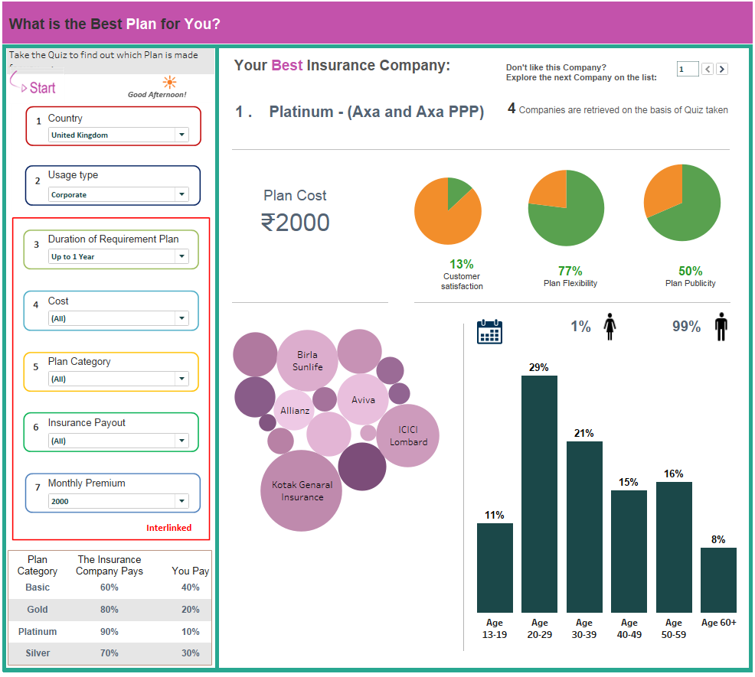

* Here if we are select the Country as India
* Usage type as corporate
* Duration of Requirement plan is Up to 2 Year
* Cost,Plan Category,Insurance payout these three options were interlinked, because its taking the filter option as only relavant values.
* If we take Country as India it will showing company count as 12
* If we take Country as UK it will showing company count as 4
* Based upon that quiz which is the suitable plan of that company shows, and based upon that Customer satisfaction, Plan flexibility,Plan publicity also shown in the Pie chart.
* For that plan showing the gender percentage difference.
* Lifetime of that customers (age difference) showing in bar chart.
* Bubble chart shown in market share value which is the best company in the market.
* If we don’t like this company then , click on the top right corner to explore the next company on the list.
* Similarly if we want to change the another country same steps follow as above.
* If we click on the Plan-Company then it will navigate to the detailed dashboard, all the customers Visits ,Transactions,Revenue of With Search/ Without Search and what are the Average Order value, Revenue Per Visit, Conversion Rate, More Valuable to search the products were showing the detailed in this dashboard.

**Impact Summary**

The first thing you'll see is a paragraph summary that explains an overview of your site's search analytics. The metrics explained here are also visualized in the rest of the Impact section.

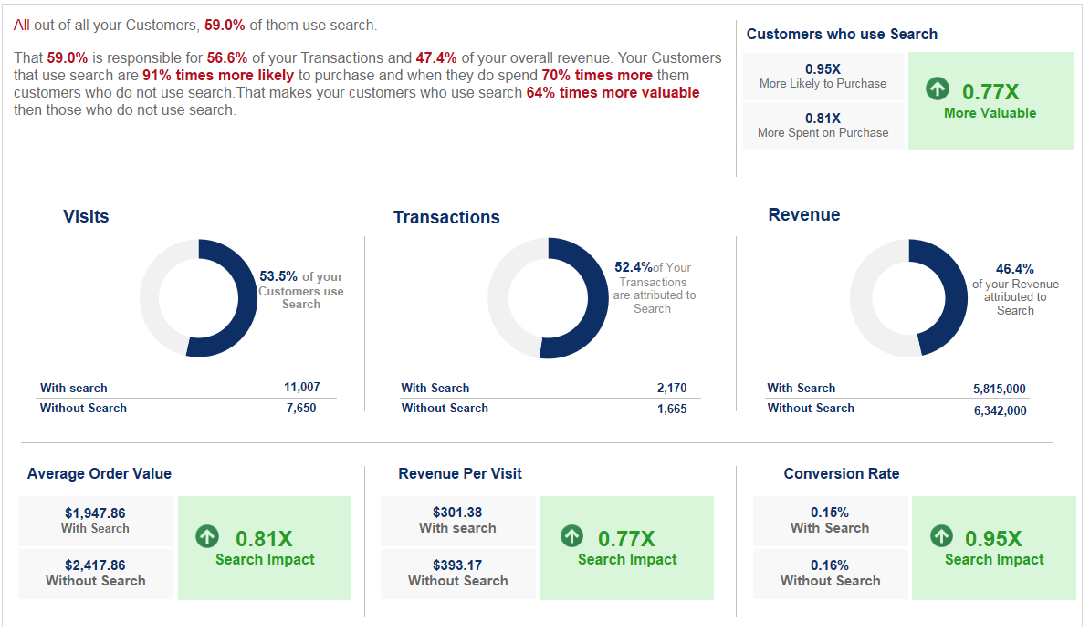

### ****Shoppers Who Use Search****

This segment shows you a high-level comparison of how your site performs when your customers use search versus when they don't. Each piece is calculated like so:

* **More Likely to Purchase:** Conversion (with search) / Conversion (without search)  
  Conversion here is calculated as Transactions / Sessions (Visits)
* **More Spent on Purchases:** Average Order Value (with search) /Average Order Value (without search)  
  Average Order Value is calculated as Revenue / Transactions
* **More Valuable:** Per Session Value (with search) / Per Session Value (without search)  
  Per Session Value here is calculated as Revenue / Sessions (Visits)

### ****Visits****

This segment can be used to give you an idea of how often your customers use site search during their visits (or "Sessions") on your site. The numbers below the chart show a breakdown of the number of sessions where customers used site search, and how many sessions where they did not. **Calculation:** Sessions where search was used / Total sessions

### ****Transactions****

The Transactions segment illustrates how often the Customers that convert on your site use search. The numbers below the chart show a breakdown of the number of transactions that occurred after using search, and how many transactions occurred without using search.

**Calculation:** Number of transactions where a customer used search / Total transactions

### ****Revenue****

This segment can be used to gauge how much your customers are spending after using search. The numbers below the chart show a breakdown of how much revenue was gained from transactions where customers used search, and how much revenue was gained from transactions that didn't use search.

**Calculation:** Revenue from transactions where customers used search / Total revenue

### ****Average Order Value (AOV)****

This segment shows a breakdown of how the Average Order Value (calculated as Revenue / Transactions) compares between customers who use search before converting, and those who don't. You can use this metric to gauge the ratio of how much more or less customers tend to spend on your site when using search.

**Calculation:** Average Order Value (with search) / Average Order Value (without search)

### ****Revenue Per Visit (RPV)****

This segment shows a breakdown of how Per Session Value (calculated as Revenue / Sessions) compares the revenue to visitor ratio between customers who use search and those who don't. You can use this metric to determine the overall value of visitors who use search. A higher ratio number indicates a combined higher likelihood of searching customers to convert and/or spend more when they visit your store.

**Calculation:** Per Session Value (with search) / Per Session Value (without search)

### ****Conversion Rate****

This segment shows a breakdown of how Conversion (calculated as Transactions / Sessions) compares among customers who use search, and those who don't. This metric can be used to give you an idea of how likely searching customers are to complete a transaction after performing a search.

**Calculation:** Conversion (with search) / Conversion (without search)